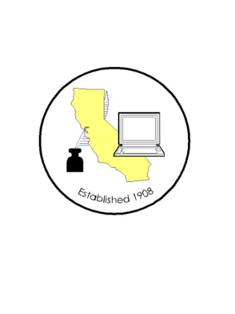

CALIFORNIA ASSOCIATION OF
CLERKS AND ELECTION OFFICIALS
July 16, 2013

TO: CACEO Members, Guests, Legislative Committee

FROM: Jill LaVine, Co-Chair
Karen Rhea, Co-Chair

SUBJECT: CACEO LEGISLATIVE COMMITTEE MEETING

LOCATION: Sofitel San Francisco Bay
223 Twin Dolphin Drive
Redwood City, CA 94065

ROOM: Bordeaux

TUESDAY, JULY 16, 2013

1:00 – 3:00 P.M.

Welcome and Introductions

Approval of June, 2013 minutes

